Key Learning- Striking and Fielding
UKS2

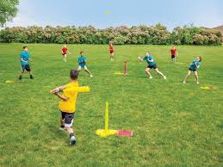
Striking and Fielding games are games where one team can score points when a player strikes a ball and runs to designated playing areas while the other team attempts to retrieve the ball and return it to prevent their opponents from scoring.

Children will take part in striking and fielding games such as rounders and kwik cricket.

By the end of UKS2, children will be able to
- To consistently strike a bowled ball
- Develop a wider range of tactics to use in a game
- Strike a bowled ball with increased accuracy and be able to begin to place the ball

Key Vocabulary

Place | To aim the ball to an area that will have maximum effect

Children should remember key vocabulary from previous keystages.

