Key Learning- Net Games
UKS2

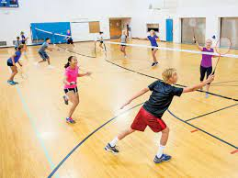
Net games are court games where a net separates the opponents (players).

Children will take part in invasion games such as badminton and tennis.
By the end of UKS2, children will be able to
- Show greater consistency when serving, sending and receiving the ball or shuttlecock
- Play cooperatively with a partner or within a team
- Cover more space
- Demonstrate good decision making when making shots/ sending the ball or shuttlecock
- Use a range of tactics

Key Vocabulary

Continuos play | A prolonged rally without intervention

Children should remember key vocabulary from previous key stages.

