Key Learning- Invasion Games
UKS2

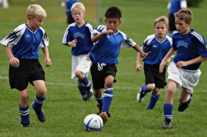
Invasion games are games in which the aim is to invade an opponent's territory and score a goal or point.
Children will take part in invasion games such as basketball, handball, hockey and football.

By the end of UKS2, children will be able to
- Understand there are different skills to suit different games
- Play in a range of positions
- Pass, receive and shoot the ball when under pressure
- Develop a range of tactics
- Apply movements to lose a defender
- Use marking and interception to improve defending

Key Vocabulary

Technique | Skill or ability relating to sport.
Support | Providing help to a team mate under pressure.
Marking | Shadowing an opponent to prevent them from receiving the ball.
Team play | Working as a group to gain a win.

Children should remember key vocabulary from previous key stages.

