Key Learning- Striking and Fielding
LKS2

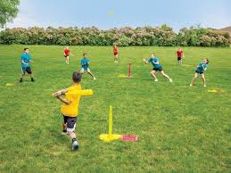
Striking and Fielding games are games where one team can score points when a player strikes a ball and runs to designated playing areas while the other team attempts to retrieve the ball and return it to prevent their opponents from scoring.

Children will take part in striking and fielding games such as rounders and kwik cricket.

By the end of LKS2, children will be able to
- Use overarm and underarm throwing skills
- Strike a bowled ball with and without bounce
- Bowl towards a target with accuracy and consistency
- Choose simple tactics to use in game situations
- To stand in positions that benefit the game when fielding

Key Vocabulary

Position | A place where someone stands.
Tactics | Carefully planned games ideas to achieve a specific end.

Children should remember key vocabulary from previous keystages.

