Key Learning- Net Games
LKS2

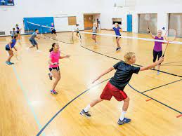
Net games are court games where a net separates the opponents (players).

Children will take part in invasion games such as badminton and tennis.
By the end of LKS2, children will be able to
- Return a ball or shuttlecock to a partner to begin a small rally
- Use basic shots
- Begin to understand tactics
- Show good footwork on the court
- Defend their own court

Key Vocabulary

Rally | A sequence of back and forth shots between players
Shot | The act of striking the ball with a desired end
Footwork | Foot movement that benefits play

Children should remember key vocabulary from previous key stages.

