Key Learning- Invasion Games
LKS2

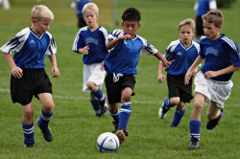
Invasion games are games in which the aim is to invade an opponent's territory and score a goal or point.
Children will take part in invasion games such as basketball, handball, hockey, football and tag rugby.

By the end of LKS2, children will be able to
- Move, pass, receive and shoot with a ball with increased control
- Defend to win and intercept a ball
- Move to help their team
- Know how to win the ball
- Develop team tactics

Key Vocabulary

Keep possession | One team keeping the ball fo a prolonged period of time.
Send | Move the ball to another person.
Receive | Having the ball sent to you.
Tactics | A planned strategy to benefit a team.
Rules | A set of instructions followed to make sure a game is safe and fair.

