Key Learning- Striking and Fielding
KS1

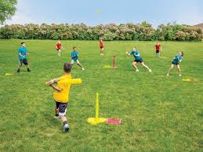
Striking and Fielding games are games where one team can score points when a player strikes a ball and runs to designated playing areas while the other team attempts to retrieve the ball and return it to prevent their opponents from scoring.

Children will take part in striking and fielding games such as rounders and kwik cricket.

By the end of KS1, children will be able to
- Move in a safe space
- Show ability to work with a partner or a small team in throwing and catching games
- Explore throwing and catching in different ways
- Hit a ball with some control and accuracy
- Bowl with some accuracy
- Develop basic tactics

Key Vocabulary

Striking | Hitting a ball with force
Fielding | Defending an area while the other team is striking (batting)
Bowling | The action of sending a ball towards a batter
Base | The object to run to in rounders
Wicket | Each of the sets of three stumps with two balls across the top at either end of the pitch, defended by a batter

