Key Learning- Net Games
KS1

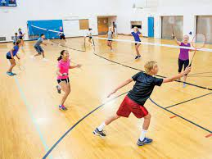
Net games are court games where a net separates the opponents (players).

Children will take part in invasion games such as badminton and tennis.
By the end of KS1, children will be able to
- Be confident that they are in a safe space
- Hit a ball with appropriate control
- Be able to send, receive (under and over arm)
- Return a ball with some accuracy
- Begin to serve the ball

Key Vocabulary

Court | The area where a net game is played
Net | The object in the middle of the court that separates the players
Serve | The act of hitting a ball or shuttlecock to start play in a net game.
Over arm | Hitting the ball or shuttecock by moving your arm in an above action.
Under arm | Hitting the ball or shuttecock by moving your arm in a below action.

