Key Learning- Invasion Games
KS1

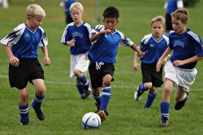
Invasion games are games in which the aim is to invade an opponent's territory and score a goal or point.
Children will take part in invasion games such as basketball, handball, hockey and football.

By the end of Key Stage 1, children will be able to
- Keep themselves in a safe space during a game
- Work with a partner in throwing and catching games
- Develop basic tactics
- Take part in a game with an opposition
- Be able to intercept a moving ball
- Understand the role of an attacker and a defender

Key Vocabulary

Attacker | A play whose job is to attack the other team’s goal to score.
Defender | A player whose job it is to protect their own team’s goal.
Team | A group of people who form one side in a competitive game or sport.
Own space | The distance from another person which feels safe.
Passing | The action of sending the ball to another team member.
Scoring | To gain a point or goal in a competitive game.
Shooting | Having a shot on goal.
Controlling the ball | Keeping possession (the ball on your team) and moving the ball with control.

