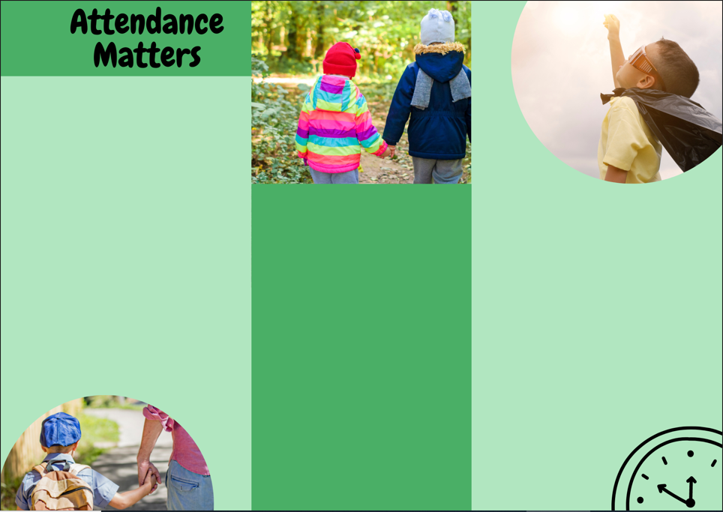



**Children learn and develop more from birth to five years than at any other time in their lives and any gaps in their learning by the end of the Early Years will, on average, double by the end of their primary years.**

**Benefits of good attendance:**

**Good habits**

It builds in young children the idea that getting up and going to school is simply what you do. Children who attend every day develop a feel for the rhythm of the week and gain a sense of security from regular routines.

Underachievement is often linked to lower attendance. For some older students this is linked to a steadily deteriorating trend in attendance which is traceable right back to Reception. Establishing good habits early is the key to future success.

**Secure relationships**

Young children find it easier to build and sustain a range of social relationships when they regularly attend nursery/ school.

**Self – esteem**

Children who rarely miss sessions at nursery/ school and arrive on time are more likely to feel good about themselves. Children who regularly miss sessions, or are generally late, can frequently experience a sense of having to try a little bit harder just to understand what is going on and what other children are talking about or doing.

**Learning and development**

Children's learning develops quickly in the Early Years. For example, once phonics begins in Reception children are learning a new phoneme every day. This means any time lost creates gaps in learning

and the more gaps there are, the harder it is for children to catch up to their peers. Good attendance ensures that children can develop at the right pace, gain confidence as they make progress, and ultimately enjoy school as they see themselves succeed.

**Every day lost = approx 6 hours of learning**

**Every week lost = approx 30 hours of learning**

**11 days lost = 94% attendance and 66 hours of learning time lost**

**19 days lost = 90% attendance, classed as a persistent absentee and 114 hours learning time lost**



**Parents can encourage good attendance by:**

* having a regular bedtime and morning routine
* preparing for the morning routine by packing a bag the night before and setting out clothes
* talking together about all the fun their child will have at nursery/ school
* arranging routine medical appointments, outings and holidays for the times their child does not attend nursery/ school if possible
* talking to their child’s key worker if there are any concerns or anxieties
* working with their child to develop healthy hygiene practices

**If you are facing difficulties getting your child into school, it is important to discuss this with school at the earliest opportunity.**

**We are here to help Mrs Corrie is available on Do Jo, via the office or her Mobile: 07928484820**

**Good attendance is essential right from the start.**

**All parents want the best for their children. Having a good education is important to ensure that children have the best opportunities in their adult life. They only get one chance at school, and your child’s future may be affected by not attending school regularly.**

**Good habits must be formed right from the start of their school life.**

**If we work together, we can ensure your child reaches their full potential.**

**Useful Contacts**

Head Teacher: Miss Kearsley

**Attendance Lead and Family Liaison Officer:** Mrs Corrie

Deputy Head Teacher: Mrs Oliver

EYFS Lead: Mrs Splaine

SENCO: Mrs Rounding Acting SENCO MS Pilling

**Telephone: 0161 921 1195**

**Email: hiltonlane.primaryschool@salford.gov.uk**

